User-generated and interactive content: as simple cure-all?

Sulhie Rafet
Student ID: 12822043
Word Count: 2062

In his article on Sprout Social’s blog, Barnhart (2020) claims that a well-considered creative content strategy is the key to successful adoption of social media. Many marketers agree on the importance of strategic and deliberate social media use as part of the brand’s overall marketing communication plans (Killian & McManus, 2015). Moreover, due to positioning content at the center of such strategies, many practitioners like Barnhart (2020) suggest types of content that would fit the brand’s identity and drive specific brand goals. This practitioner claims that engagement is driven by user-generated and interactive content; thus, brands should include them in their social media. According to him, brands can create posts as “simple as asking a question or posting a poll [which] can do the trick”. From this article’s perspective, user-generated and interactive content is present in many brands’ social media channels not only due to their trendiness and success but also due to the fact that social media platforms allow for greater creative opportunities.
The arguments in this article describe user-generated and interactive content as successfully leading to higher levels of engagement on social media. Such is the case for three popular campaigns by Coca-Cola, Calvin Klein and Wendy’s. Firstly, Coca-Cola’s “Share a Coke” (See Appendix A for example user-generated content) campaign triggered a myriad of user-generated content both online and offline and thus, becoming one of the most fruitful interactive campaigns (Windle, 2016). By putting people’s names on their bottles, Coca-Cola encouraged their customers to “share a coke” with a friend or anyone with that name. Later, this campaign evolved and included nicknames, professions and even song lyrics (this transformed into a different campaign named “Share a Coke Song” with Selena Gomez, an example of which can also be found in Appendix A). The campaign began in 2011 in Australia but quickly spread across the globe and is still at use today featuring other prizes alongside it. What made the “Share a Coke” campaign so successful and engaging for customers to produce their own content was its simplicity (something that Barnhart (2020) also proposes) and its relatability to anyone in the world.
Secondly, Calvin Klein’s “#mycalvins” campaign on Instagram (See Appendix B for examples) is yet another example of simplicity and efficiency. With the help of influencers such as Billie Eilish, Justin Bieber, Kendall Jenner, youtubers, etc. as well as their own Instagram channel, Calvin Klein created the body-positive and empowering hashtag of #mycalvins. In this way, any consumer, no matter their body shape or who they are, can showcase how they wear Calvin Klein underwear by posting a photo on Instagram. The campaign was powerful and led to high amounts of user engagement due to its relevance. By prompting people to express themselves, be who they are confidently and unapologetically, Calvin Klein put their fresh and cool brand identity in the limelight.
Last but not least, Wendy’s uses its Twitter channel to drive traffic and purchase as well as build brand awareness. These goals, however, require research into their target markets and user personas. Thus, Wendy’s rely on interactive Twitter content to learn more about their customers. For instance, asking their Twitter followers for their food preferences (See Appendix C) indicates that the use of a simple question can highly engage and involve users (it generated almost 6K votes). By asking a simple product-related question, Wendy’s not only gathers product opinions and possible consumer-led innovations, but also builds deeper connections with their consumers. In this way, people feel involved in the process and can also express any feelings towards Wendy’s burgers. Once again, Barnhart’s (2020) claim of interactive content generating positive feelings and high levels of engagement seems to be proven.
The above mentioned three real-life examples show how Barnhart’s (2020) view that simple and creative campaigns that are either interactive or generate brand-related user content can be quite successful for a brand's social media activities. However, as much as interactive content and content that prompts consumers to develop their own brand-related content, leads to greater engagement and more positive feelings towards the brand on social media, there are still boundary conditions to consider. These would include platform used, type of brand, how a story is implemented within the campaign that triggers user-generated content as well as whether the campaign is based on community and user persona research. It is expected that the literature would have found similar results that these two types of content would be successful but only if the brands carefully contemplate on how and when to utilize them. Moreover, engagement metrics may be different for each campaign and each brand, thus, Barnhart’s (2020) claims seem to overgeneralize and oversimplify the concept of engagement. Another consideration would be on how the brand leverages the user content after its creation. Unlike the practitioner’s assertion that simplicity and creativity are key to these types of content being engaging, they are not an easy cure-all, but rather brands should approach this content carefully.
Firstly, it should be noted that research agrees (Busser & Shulga, 2018; Christodoulides, Jevons, & Bonhomme, 2012; Smith, Fischer, & Yongjian, 2012; Vanden Bergh et al., 2011) on the effectiveness of user-generated and interactive content (both of which are essentially prompted by the brand and expect consumer/user interaction and involvement) to generate large amounts of engagement as Barnhart (2020) states. However, this research also attributes consequences such as positive brand attitudes (Vanden Bergh et al., 2011), brand loyalty (Busser & Shulga, 2018), increased purchase intentions (Vanden Bergh et al., 2011), credibility and trustworthiness (Christodoulides et al., 2012), and co-creation of the brand (Wilson, Murphy, & Fierro, 2012) to user-generated content. Moreover, engagement is not as simple as in Barnhart’s (2020) word, but is a rather vague concept in both academia and practice. In academia, it may depict either positive emotions towards a brand, or interactions and communications with a brand or even any brand-related activities (Dessart, Veloutsou, & Morgan-Thomas, 2016). This leads to further complications in practice. In social media, engagement is also viewed through a multitude of metrics. For instance, Facebook provides metrics such as organic and lifetime ad reach, impressions, cost per click, etc. (Moro, Rita, & Vala, 2016). Another pitfall of engagement is that it is an inadequate measure of all brand goals on social media. Each brand should define its measurements depending on the goals it sets for each campaign (Moro et al., 2016). If a brand receives high numbers of engagement such as likes and shares, for example, this may not show whether these users are willing to purchase the brand’s products or services or even all types of sentiments and attitudes online consumers feel towards the brand. Thus, marketers should not fully follow Barnhart’s (2020) vague conclusion that user-generated and interactive content produces high amounts of engagement. It does, but under certain circumstances. Whenever deciding whether and how to utilize interactive content that generates user traffic, they should focus on functionality and relevance to their brand identity and goals.
This practitioner article and academia also differ on the fact that much research attributes multiple boundary conditions to why interactive and user-generated content are successful. This is due to the fact that despite their advantages, user-generated and interactive types of content should be carefully considered due to being out of organizational control (Vanden Bergh et al., 2011). In this way, brands should not only be aware of the fact that their campaign may backfire, but it should also be meticulously crafted in the back-end, so that it eventually is perceived by consumers as simple as in Barnhart’s (2020) claims.
User-generated and interactive content’s effectiveness and success could be affected by external factors such as social media platforms and types of user-generated content. As per Smith et al.’s (2012) discovery that user-generated content differs across social media platforms, brands need to decide how, when and where they will stimulate the production of such. For instance, in Twitter user-generated content the brand plays a more central role than any other social media sites (Smith et al., 2012). This, however, introduces a level of risk to Twitter user-generated content because both negative and positive messages about a brand may spread quicker. The aforementioned Wendy’s example was risky and could have backfired, but eventually proved beneficial for the brand looking at the amount and type of engagement it generated. Through this interactive content, Wendy’s also learned some information about their audience and their preferences, which can contribute to future social media content campaigns. While platform differences exist, each one provides both benefits and disadvantages that marketers need to take into consideration for their next interactive content that promotes user involvement. Moreover, depending on what the brand prompts users to create, different types of interactive content may receive varying levels of engagement and interaction. According to Moser & Van Eijkeren (2016), user-generated content is most successful whenever visual aspects are incorporated as part of it. In the Calvin Klein example above, the brand has chosen to elicit user engagement by asking them to share images of themselves. This tactic proved successful and engaging. However, the Wendy’s example encourages users to share text opinions, which worked for their brand, platform and consumers. Thus, when building interactive social media campaigns, markeretes should not follow trends, but rather take into account the platform characteristics, their brand identity and potentially, users.
Apart from these boundary conditions, more internal brand factors need to also be considered before developing campaigns that are interactive and lead to user-generated content. These aspects include brand characteristics (industry and B2B/B2C), appeal to consumers and brand communities. Not all brands may benefit or may require campaigns with user-generated content to drive high amounts of engagement. For instance, the tourism and hospitality industry produces the most user-generated and word-of-mouth content, which can contribute to increased sense of brand loyalty (Busser & Shulga, 2018; Wilson et al., 2012). However, levels and types of engagement in such content in a business-to-business (B2B) brand may respectively be lower and different (Karjaluoto, Ulkuniemi, Huotari, Saraniemi, & Mäläskä, 2015). In the B2B case, brands are encouraged to identify the full range of online users before developing any social media content, including corporate users (other firms) that may engage in online conversations (Karjaluoto et al., 2015). This may not be the case in a business-to-consumer case, however, user types and their personalities are still a relevant consideration. Some consumers may not be willing to engage in such content while those that do - may carefully choose how and where. In the hospitality industry, Swiss and British users were more likely to post visual and textual reviews on Facebook unlike their Spanish counterparts who preferred mostly textual reviews on TripAdvisor (Wilson, Murphy, & Fierro, 2012).
Thus, a brand’s social media content should not disregard thorough research into user personas and their characteristics. Some of these users may even be opinion leaders and thus steer both conversations and the production of further user content (Morrison, Cheong, & McMillan, 2013). Through a meticulous analysis of the types of online users that the brand engages with and discovering leaders, marketers can develop campaigns that are relevant to these individuals. Furthermore, some online users will produce more user-generated content if they perceive the brand to be co-created with other similar users (rather than being solely marketer-induced) and if the brand brings a sense of community (Christodoulides et al., 2012). Thus, alongside the thorough research on user personas, marketers should also analyze the community around the brand, because individuals share their preferences, engage in conversations, and discuss brand-related issues within these communities (Morrison et al., 2013). Such data can contribute to the generation of better and more appropriate interactive social media content. In this way, social media content is not as simple as it looks, but becomes effective and relevant only after a thorough analysis of the brand and its environment.
The claim in Barnhart’s (2020) article mostly coincides with academic opinions on the power of user-generated content to influence consumer opinions and engagement levels. However, the argument is too vague and broad; thus, ignoring the multitude consequences of user-generated content. Moreover, by sugarcoating the complexity of such brand content and presenting it as a simple cure-all, Barnhart (2020) glosses over the need for brands to perform an in-depth analysis before developing campaigns with interactive elements. Academia has shown that only through such analysis, brands can develop a tailored social media strategy for every online stakeholder that also fits their brand characteristics.

References

Barnhart, B. (2020). How to build your social media marketing strategy for 2020. Retrieved
February 25, 2020, from https://sproutsocial.com/insights/social-media-marketing-strategy/.

Busser, J. A., & Shulga, L. V. (2019). Involvement in consumer-generated advertising: effects of
organizational transparency and brand authenticity on loyalty and trust. International Journal of Contemporary Hospitality Management, 31(4), 1763-1784.

Christodoulides, G., Jevons, C., & Bonhomme, J. (2012). Memo to marketers: Quantitative
evidence for change: How user-generated content really affects brands. Journal of advertising research, 52(1), 53-64.

Dessart, L., Veloutsou, C., & Morgan-Thomas, A. (2016). Capturing consumer engagement:
duality, dimensionality and measurement. Journal of Marketing Management, 32(5-6),
399-426.

Karjaluoto, H., Ulkuniemi, P., Huotari, L., Saraniemi, S., & Mäläskä, M. (2015). Analysis of
content creation in social media by B2B companies. Journal of Business & Industrial
Marketing. 30(6), 761-770.

Killian, G., & McManus, K. (2015). A marketing communications approach for the digital era:
Managerial guidelines for social media integration. Business Horizons, 58(5), 539-549.

Morrison, M. A., Cheong, H. J., & McMillan, S. J. (2013). Posting, lurking, and networking:
Behaviors and characteristics of consumers in the context of user-generated content.
Journal of Interactive Advertising, 13(2), 97-108.

Moro, S., Rita, P., & Vala, B. (2016). Predicting social media performance metrics and
evaluation of the impact on brand building: A data mining approach. Journal of Business Research, 69(9), 3341-3351.

Moser, C., & Van Eijkeren, A. (2016). User-generated content? Get serious! Understanding the
interactions between organisations and customers on social media. International Journal
of Business Environment, 8(3), 284.

Smith, A. N., Fischer, E., & Yongjian, C. (2012). How does brand-related user-generated content
differ across YouTube, Facebook, and Twitter?. Journal of interactive marketing, 26(2), 102-113.

Vanden Bergh, B. G., Lee, M., Quilliam, E. T., & Hove, T. (2011). The multidimensional nature
and brand impact of user-generated ad parodies in social media. International Journal of Advertising, 30(1), 103-131.

Windle, K. (2016). Share a Coke and a Word: How Coca-Cola Captured Millennials Through
Word of Mouth Marketing. Retrieved March 15, 2020, from
https://medium.com/@kwindle/share-a-coke-and-a-word-how-coca-cola-captured-millen
nials-through-word-of-mouth-marketing-44896573d21c

Wilson, A., Murphy, H., & Fierro, J. C. (2012). Hospitality and travel: The nature and
implications of user-generated content. Cornell Hospitality Quarterly, 53(3), 220-228.

Appendix A
Coca-Cola “Share a Coke” campaign

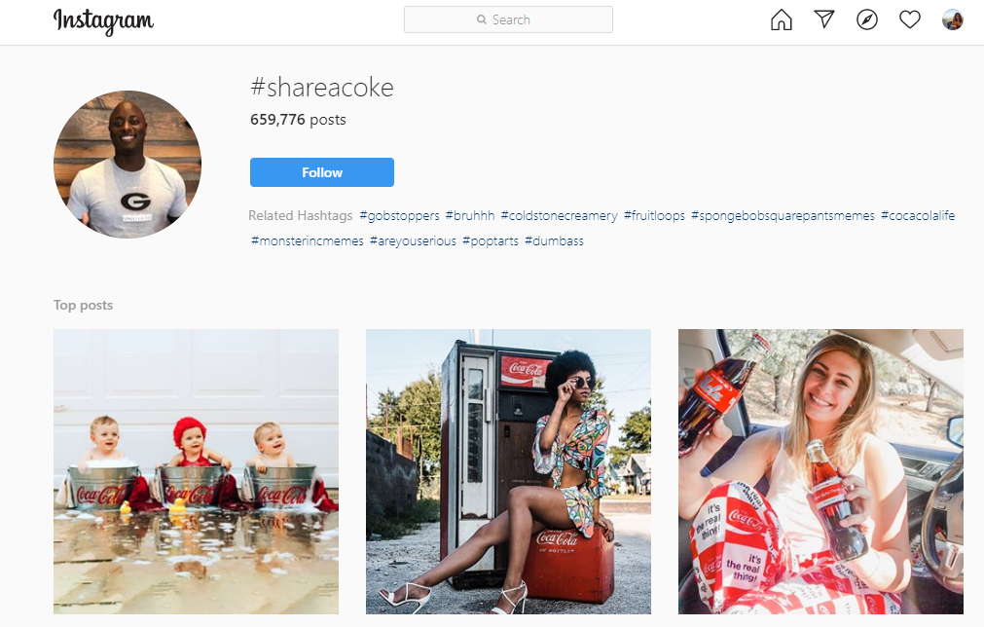

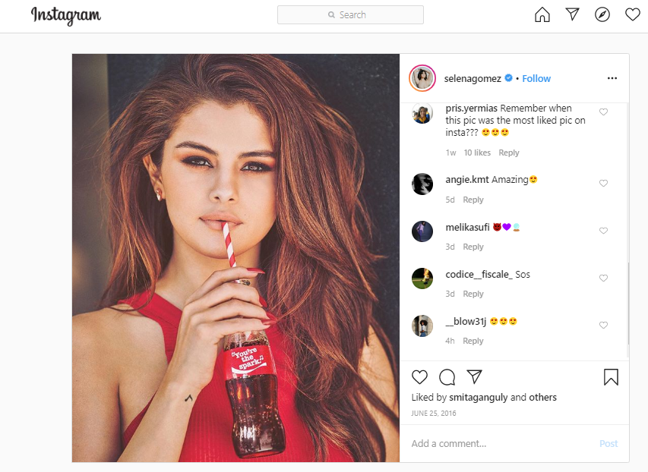
Appendix B
Calvin Klein “#mycalvins” campaign

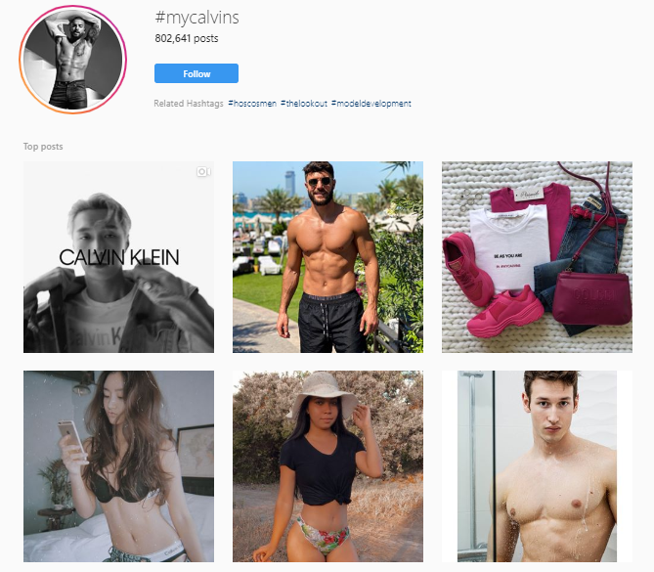
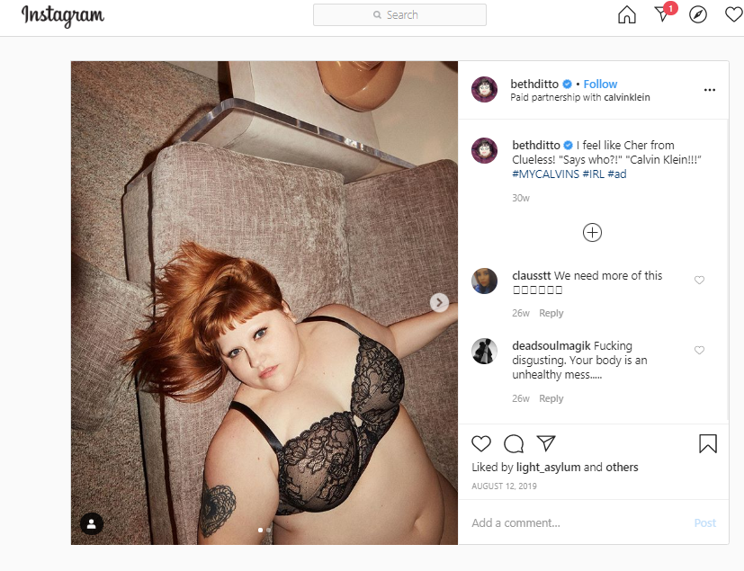
Appendix C
Wendy’s use of interactive content on Twitter

