Why consumers choose what they choose?
Student ID: 2134504
Word Count: 2687
12/15/2016

In the world of consumer behaviour, there is no definite answer to the question of why consumers choose what they choose. Many researchers have tried explaining consumer motivations in making certain choices, but there is no unified model. This is the case, because human beings are creatures who can act on both rational and irrational motives, which either push or pull individuals towards a decision (Forbes, 2015, p.6-7). Furthermore, consumers are often influenced by situational cues and environmental circumstances. The Western consumer society is characterized by mass customisation and growing consumer options. A sociological perspective on consumerism also considers that individuals and their freedom in contemporary society are being defined by their consumer choices (Miles, 1998). Consumers are having increasingly more options when choosing products or services, resulting in a pool of possibilities and high expectations. Moreover, individuals are seeking to buy the benefits of products/services, depending on what their conscious and unconscious needs are (Evans et al., 1996, p.27). Therefore, marketers’ task is to meet expectations in order to satisfy both of consumer’s rational and emotional needs. Marketers try to understand the most they can about their target market and create such a relationship that satisfies consumers and results in brand loyalty. This leads to a three-way connectivity between consumers, marketers and environment; all of which influence an individual’s motivation. Social media also stimulates motivational drives by not only satisfying consumers’ emotional needs, but also providing a platform for expression of consumer choices. Often one explanation for a particular consumer decision is not valid for others, therefore marketers should try to be innovative, up to date with current trends and their target market’s needs and influences as well as draw on various theories and models to explain consumer’s unpredictable behaviour. Individual consumption practices vary along the spectrum; they might be motivated by psychological emotions and desires, symbolic and social needs (both online and offline), environmental factors, and by developments in digital technologies.
This essay will draw on psychological, sociological, and anthropological approaches to the understanding of consumer motivations. Therefore, the essay will first provide theoretical perspectives on Maslow’s theory (1943) of unconscious needs, which will be reviewed and criticised. A debate on whether marketers create or satisfy consumer needs will follow, but dismissed to support the view that advertising endeavours to uncover individuals’ pre-existing, unconscious needs and desires. Then, consumer motivation as a product of individuals’ self-awareness in the social world will be explored sociologically and anthropologically. It should be noted, however, that this is not an extensive review of consumer motivations, but rather a suggestion of marketing situations that utilise Maslow’s theory as a basis, but also go beyond his hierarchy of needs. Furthermore, the essay will critically assess the relevance of social media to the study of consumer motivations. Throughout the essay, theories will be linked to current consumer choice situations and advertising campaigns, in order to introduce a layer of practicality to the analysis. Marketing campaigns often cannot relate to all factors along the spectrum of internal-external influences on individual consumer choices, therefore marketers should seek to customise their campaigns and satisfy needs that are relevant to the target market (unconscious needs), to the context and culture (sociological, anthropological) and product category (high or low involvement).
Maslow and theoretical perspectives on consumer motivation
In the modern consumer society, marketers are competing against each other to attract consumers and build loyalty by triggering individuals’ conscious and unconscious needs. As consumers often do not choose products/services rationally, Maslow’s hierarchy of needs (Appendix A) can be a useful tool in analysing such unconscious and emotional consumer decisions. Thus, marketers regularly target consumers’ needs at various levels of the hierarchy, however according to Acevedo (2015), self-actualisation is not a finished state, but rather fluctuates due to consumers’ constant strive to achieve it. For example, through its newest campaign named Time is precious (Appendix B) Nike targets consumers by prompting them to aim for self-actualisation by spending their time running/exercising, thus not wasting it on social media or TV. The simplistic ad attempts to both stir consumers’ consciousness and satisfy an unconscious need of realising one’s potential through self-actualisation. This confirms Maslow’s contemporary relevance. Moreover, many researchers praise Maslow’s work such as Lambin and Schuiling (2012, p.113) who argue that Maslow has provided a “multidimensional structure of needs”. The latter, according to Pincus (2004) are often unmet and unconscious, thus pushing the individual to seek their satisfaction. This is helpful for marketers to create campaigns that trigger the individual’s emotional and unconscious responses.
However, other theorists are sceptical of the universality of Maslow’s theory and assert the fact that many elements, beyond the hierarchy, interplay in the development of consumer motivations. Maslow’s model is problematic due to its relevance solely to Western individualistic values (Hanley, and Abell, 2002; Kellerman, 2014). Thus, his hierarchy of needs does not accommodate to various cultural and environmental differences. Furthermore, not all individuals in a society move up the same manner as others do (Evans et al., 1996). In this way, the hierarchy of needs cannot be generalised for larger societies. The generalisation problem arises from the fact that Maslow did not provide empirical evidence to his theory. Therefore, Tay and Diener (2011) tested it across 123 countries and found that there are indeed some universal needs (mostly physiological ones), but there are also societal factors at play. Society also influences the way sexual motivations are formed. According to Kenrick et al. (2010, p.296), these desires “should be treated distinctly from basic survival needs such as hunger” because they might occur due to social pressures. Such influences will be discussed later to suggest how a consumer can be motivated by external factors.
The above mentioned criticisms are not enough to completely reject Maslow’s pyramid of unconscious needs that drive individuals. His theory still remains at the basis of many marketing campaigns, which also integrate further theories for successful consumer satisfaction. Many consumers make decisions based on a product’s category; whether it is high or low involvement. For instance, consumer choices are less rational for low involvement products, which do not involve planning or conscious thinking. As individuals are motivated by both rational and irrational drives, marketers focus on either of these in the creation of a marketing campaign. Some researchers (Foxall and Goldsmith, 1994), nevertheless, undertake a multidimensional approach in the marketing of products that satisfy needs from more than one level of Maslow’s hierarchy. The same product can be marketed as having the ability to satisfy needs from various levels, in order to make it more appealing. Throughout the years, Coca-Cola (See Appendix C for a mix of campaigns) has been advertised as a product that works on physiological, belonging, esteem and self-actualisation level. Being a low involvement product, Coca-Cola not only creates campaigns to show how it can satisfy physiological needs (thirst), but also its marketing team endeavours to attach further meanings to the product such as sharing with loved ones, happiness, self-actualisation through self-expression, all found at higher levels of Maslow’s hierarchy. Thus, a Coke becomes unconsciously desirable on multiple levels, including associations of fun and happiness. Emotional advertising has become an important part of Coca-Cola’s marketing strategy, since they have achieved connotations of happiness, affection, and friendliness to their brand through constant repetition (Faber et al., 2012) of such feelings as it can be seen in the examples from Appendix C. All of these campaigns concentrate on the similar idea of how the product can bring different types of people together and make them a community. Such product versatility has proven effective to keep the brand desirable and able to meet unconscious needs. Alternatively, there are also individuals who choose despite their consciousness. According to Cluley (2015), these choices, as any other consumption practices, communicate symbolic meanings and social standing while repressing views on morality, ethics or health. For example, individuals are aware of the negative effects of smoking on their health, however they still continue consumption due to raw unconscious desires, while restraining their consciousness. Here, the interplay between rationality and irrationality is visible
In the struggle between conscious and unconscious motivations, a debate has emerged on whether marketers satisfy consumer’s latent and pre-existing needs or they artificially create such and instil them in consumers to generate profit. Many argue that advertising plays with consumer emotions and generates demand for products/services that consumers do not need. However, only the emergence of the debate can be considered logical due to the fact that advertising campaigns’ messages function on a deep emotional level. Marketing reminds consumers of their freedom and ability to satisfy latent needs through certain products/services (Evans et al., 1996, p.23). As such, the field of consumer behaviour handles non-tangible concepts, often not even comprehended by the individuals themselves. Moreover, it is up to the consumer to decide on how and what needs and desires have been satisfied through the purchase of a certain product/service. This further complicates the exposure of meanings behind consumer behaviour due to unconscious motivation. Dichter’s pioneering work into motivation research through in-depth interviews (Schwarzkopf and Gries, 2010) is not sufficient to fully outline human motivations. Motivation research has been defined with struggles to create unified models of conscious and unconscious needs (Appendix D, Appendix E). These provide a better understanding of what influences consumers’ choices, however as most of their needs are suppressed, they can hardly be understood fully, since even the consumers themselves are unaware of their raw and most basic desires. Thus, marketing develops product demand that is derived from an inherent latent need following the model of car purchase due to the fact that the “car is a derived need with respect to the absolute generic need of individual mobility” (Lambin and Schuiling, 2012, p.100). Additionally, a consumer may acquire a car because of their need to be accepted socially. It has been proven that individuals possess innate needs, which marketers work to satisfy. Thus, it can be concluded that advertising does not artificially cultivate or instil needs in consumers, but rather triggers more general latent needs, such as those described by Maslow. Therefore, Maslow’s hierarchy of needs should not be ignored in the process of comprehension of consumer needs, but seen alongside other theories, motivations, and social factors.
Sociological and anthropological perspectives on consumer motivation (as a product of the interaction between the self and the external world/society)
As it has already been mentioned, consumer behaviour is often affected by individuals’ experiences in a specific society or context. The environment and surrounding social groups define how a consumer is motivated. Consumption is often based on identity, which is fluid due to being moulded by situational factors in an unconscious process (Oyserman, 2009). Identity-shaping occurs on a deep emotional level, exactly where Maslow’s hierarchy rests. Through this process, consumers are influenced by social groups, within which individuals seek or provide opinions. External factors drive some individuals to be opinion leaders in order to attain higher social status (Foxall and Goldsmith, 1994; Rose and Kim, 2011, p.211; Kotler et al., 2012). These individuals are concerned not only with how they will be perceived by others but also with how they can sway a group’s opinion and motivate individuals’ consumption practices. In the relationship between individuals and groups, people are driven by their need to belong and be part of a community (Baumeister and Leary, 1995), an idea constructed on the basis of Maslow’s level of belonging. This will be further explained through Victoria’s Secret advertising campaign Perfect Body (Appendix F). This ad received backlash due to its controversial ideal of a perfect woman’s body and lack of diversity (Bahadur, 2014). Despite this, the campaign targets consumers who have the unconscious need for a perfect body that possesses sexual appeal. The brand attempts to show how all of this could be accomplished through purchase of Victoria’s Secret undergarments. Choosing these products is not solely due to physiological, sexual drives, but because they are mostly targeted to women, it is also about self-actualisation and achieving a feeling of beauty and perfection, similar to that of the women in the advertisement. Furthermore, as luxurious products, Victoria’s Secret intimate apparel are consumed for hedonic and self-esteem purposes, which are unconscious drives (Hume and Mills, 2013). Except these intrinsic drives, this campaign relies on the symbolic meaning of Victoria’s Secret undergarments. Through a sociological perspective, such symbolic meanings of products, considered as artefacts of social implications within a culture, can create “product-centered identity” (Shank and Lulham, 2016, p.619), thus consumers become Victoria’s Secret-owners. These products generate meanings of sexual attractiveness within society due to individuals’ concern with how they will be perceived socially. Thus, as much as human motivation is an unconscious process related to identity formation, it can also be invoked through societal and contextual factors, driving consumers towards consumption choices that can satisfy those desires.
Consumer motivation and digital technologies
Trends in consumer motivations also develop through time with new digital technological changes. As such, social media’s implications of connectivity and being reachable at any time provide new avenues for advertising as well as building consumer relationships, understanding and even meeting consumers’ latent needs. Kim and Drumwright (2016) argue that both intrinsic and extrinsic factors affect consumer motivations on social media, but also stress on the need for marketers to develop campaigns around the idea of social relatedness. Consumers choose certain social media due to its ability to emotionally connect people. Recently, there has been a trend of YouTube influencers affecting consumer choices through endorsement videos of their own (the influencers’) products. For instance, the YouTuber Zoella introduced a new line of beauty products and is promoting them to her audience (Appendix G). As this social media platform creates communities (Burgess and Green, 2009), YouTubers such as Zoella can easily advertise their own products to their followers due to already having built a relationship with them. Consumers feel desire to resemble Zoella by imitating consumption practices through the social influence powers that she as a YouTuber and celebrity possesses (Kapitan and Silvera, 2016). This occurs due to desire to conform to social norms. Thinking of the YouTuber as a brand, it is visible that brand tribalism and connection to others within that community influences not only consumer choices but also brand reputation (Veloutsou and Moutinho, 2009). Consumers are motivated to choose due to tribe norms, irrespective of the fact that these social groups are virtual. However, as much as digital technologies provide new possibilities for targeting consumer needs, websites’ landing pages continue to exhibit stimulation based on Maslow’s hierarchy of needs. For instance, a website such as Lynda.com, which provides online courses on various subjects, has built a landing page (Appendix H) which triggers consumers’ esteem (learning a new skill for self-esteem, improved perception by others, and sense of achievement) and self-actualisation needs (learning provides consumers with the ability to progress towards their potential by having abilities in various areas). The message is that through these online courses, consumers can satisfy needs from more than a single layer of Maslow’s hierarchy. Moreover, Lynda.com is aware of the fact that consumers would like to develop skills in multiple subjects. Thus, they are targeting consumers through the tagline “Limitless learning, limitless possibilities,” suggesting a new demand for more options and diversity. This example shows how marketers address Maslow’s hierarchy of needs, but also adjust to new trends. In this way, digital technologies contribute new methods to emotionally connect with people, while still considering Maslow’s hierarchy as the basis to satisfy consumers’ latent needs.
Therefore, the creation of successful marketing campaigns and stable customer relationships relies on the marketer's’ ability to fully comprehend their consumers. Consumer choice motivations are so complex, that they are the result of the interplay of all above-mentioned factors beyond internal latent desires. Marketing strategies often implement a deeper understanding of rational choices and unconscious motivations in the construction of closer relationships with target market. Thus, awareness of Maslow’s hierarchy of needs, of social and contextual influences as well as new trends in digital technologies help marketers paint an overall picture of who their consumers are and why they choose what they choose.

Bibliography
Acevedo, A. 2015. A Personalistic Appraisal of Maslow’s Needs Theory of Motivation: From ‘Humanistic’ Psychology to Integral Humanism. Journal of Business Ethics, pp.1-23. doi:10.1007/s10551-015-2970-0.
Bahadur, N. 2014. Victoria’s Secret ‘Perfect Body’ Campaign Changes Slogan After Backlash. Huffington Post. [Online]. 11 July. [Accessed 6 December 2016]. Available from: http://www.huffingtonpost.com/2014/11/06/victorias-secret-perfect-body-campaign_n_6115728.html
Baumeister, R., Leary, M. R. 1995. The need to belong: Desire for interpersonal attachments as a fundamental human motivation. Psychological Bulletin. 117, pp.497-529.
Burgess, J., Green, J. 2009. The Entrepreneurial Vlogger: Participatory Culture Beyond the Professional-Amateur Divide. In: Snickars, P., Vonderau, P. eds. The YouTube Reader. Lithuania: Logotipas, pp.89-107.
Cluley, R. 2015. Consumption and repression. Marketing Theory. 15(3), pp.365-379.
Evans, M. J., Moutinho, L., Raaij, W. F.V. 1996. Applied consumer behaviour. London: Addison-Wesley Publishing Ltd.
Faber, R. J., Duff, B. R. L., Nan, X. 2012. Coloring Outside the Lines: Suggestions for Making Advertising Theory More Meaningful. In: Rodgers, S., Thorson, E. eds. Advertising Theory. New York: Routledge, pp.18-32.
Forbes, D. 2015. The Science of Why: Decoding Human Motivation and Transforming Marketing Strategy. New York: Palgrave Macmillan.
Foxall, G. R., Goldsmith, R. E. 1994. Consumer psychology for marketing. London: Routledge.
Hanley, S. J., Abell, S. C. 2002. Maslow and Relatedness: Creating an Interpersonal Model of Self-Actualization. Journal of Humanistic Psychology. 42(4), pp.37-57.
Hume, M., Mills, M. 2013. Uncovering Victoria's Secret: Exploring women’s luxury perceptions of intimate apparel and purchasing behaviour. Journal of Fashion Marketing and Management: An International Journal. 17(4), pp.460-485.
Kapitan, S., Silvera, D. H. 2016. From digital media influencers to celebrity endorsers: attributions drive endorser effectiveness Marketing Letters. 27, pp.553–567.
Kenrick, D.T., Griskevicius, V., Neuberg, S. L., Schaller, M. 2010. Renovating the Pyramid of Needs: Contemporary Extensions Built Upon Ancient Foundations. Perspectives on Psychological Science. 5(3), pp.292-314.
Kellerman, A. 2014. The Satisfaction of Human Needs in Physical and Virtual Spaces. Physical and Virtual Spaces, The Professional Geographer. 66(4), pp.538-546.
Kim, E., Drumwright, M. 2016. Engaging consumers and building relationships in social media: How social relatedness influences intrinsic vs. extrinsic consumer motivation. Computers in Human Behavior. 63, pp.970-979.
Kotler, P., Keller, K. L., Brady, M., Goodman, M., Hansen, T. 2012. Marketing Management. 2nd edn. England: Pearson Education Limited.
Lambin, JJ, Schuiling, I. 2012. Market-Driven Management: Strategic and Operational Marketing. 3rd edn. Hampshire: Palgrave Macmillan.
Martin, N., Morich, K. 2011. Unconscious mental processes in consumer choice: Toward a new model of consumer behavior. Journal of Brand Management. 18(7), pp.483-505.
Maslow, A. H. 1943. A Theory of Human Motivation. Psychological Review. 50(4), pp.370-96.
McLeod, S. 2007. [updated 2016]. Maslow’s Hierarchy of Needs. [Online]. [Accessed 6 December 2016]. Available from: http://www.simplypsychology.org/maslow.html .
Miles, S., 1998. Consumerism: as a way of life. London: SAGE Publications Ltd.
Oyserman, D. 2009. Identity-based motivation and consumer behavior. Journal of Consumer Psychology. 19, pp.276-279.
Pincus, J. 2004. The consequences of unmet needs: the evolving role of motivation in consumer research. Journal of Consumer Behaviour. 3(4), pp.375-387.
Rose, P., Kim, J. 2011. Self-Monitoring, Opinion Leadership and Opinion Seeking: a Sociomotivational Approach. Current Psychology. 30, pp.203-214.
Schwarzkopf. S., Gries, R. 2010. Ernest Dichter, Motivation Research and the ‘Century of the Consumer’. In: Schwarzkopf. S., Gries, R. ed. Ernest Dichter and Motivation Research: New Perspectives on the Making of Post-War Consumer Culture. London: Palgrave Macmillan, pp.3-40.
Sociology Compass 10/7 (2016), 613–622, 10.1111/soc4.12381
Symbolic Interaction with Consumer Products: An Affect
Control Theory Approach
Daniel B. Shank
1
*
and Rohan Lulham
Sociology Compass 10/7 (2016), 613–622, 10.1111/soc4.12381
Symbolic Interaction with Consumer Products: An Affect
Control Theory Approach
Daniel B. Shank
1
*
and Rohan Lulham
Sociology Compass 10/7 (2016), 613–622, 10.1111/soc4.12381
Symbolic Interaction with Consumer Products: An Affect
Control Theory Approach
Daniel B. Shank
1
*
and Rohan Lulham
Shank, D. B., Lulham, R. 2016. Symbolic Interaction with Consumer Products: An Affect Control Theory Approach. Sociology Compass. 10(7), pp.613–622.
Tay, L., Diener, E. 2011. Needs and Subjective Well-Being around the World. Journal of Personality and Social Psychology. 101(2), pp.354–365.
Veloutsou, C., Moutinho, L. 2009. Brand relationships through brand reputation and brand tribalism. Journal of Business Research. 62, pp.314–322.

Appendix A: Maslow’s Hierarchy of Needs
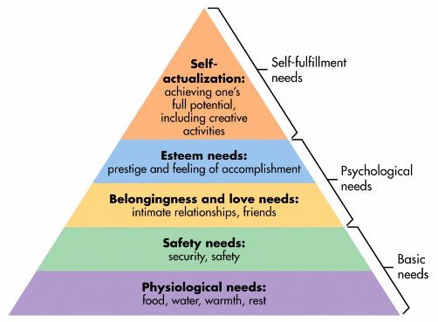
Figure 1, Maslow’s Hierarchy of Needs (McLeod, 2007)
According to Maslow, what individuals have in common are their unconscious needs, constructing a pyramid-shaped hierarchy (Figure 1). Thus, people are motivated, in an unconscious process, to achieve these by satisfying them level by level (McLeod, 2007). As individuals have satiated desires from one level, they are motivated to move up the hierarchy and work on the next order of needs. These needs are innate and latent (Evans et al., 1996).

Appendix B: Nike advertisement Time is precious
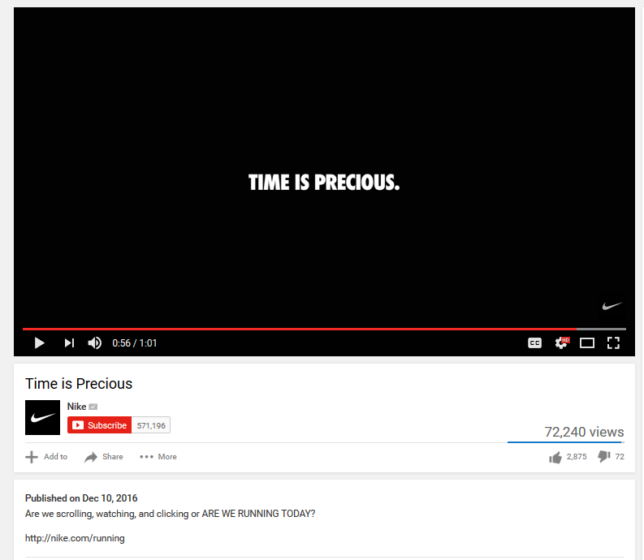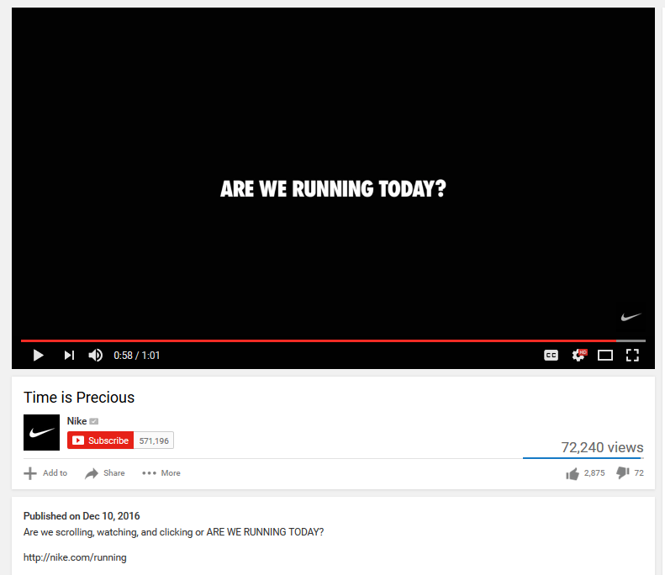
Figure 2, Time is precious campaign. 2016. Nike. At: https://www.youtube.com/watch?v=hncWOZawsWo. [Accessed 12 December 2016]
Nike’s advertisement (Figure 2) is a simple way to motivate people to exercise (run) by promoting how their products can satisfy self-actualisation needs for self-improvement. The short video is narrated by a robot-like voice, which makes references to popular culture. These references expose distressing facts about contemporary individuals’ habits to spend too much time online, without exercising. Nike exposes these consumption practices and strives to inspire or rather push individuals to run, thus improving themselves by using the brand’s sports gear.
Appendix C: Coca-Cola: a mix of marketing campaigns
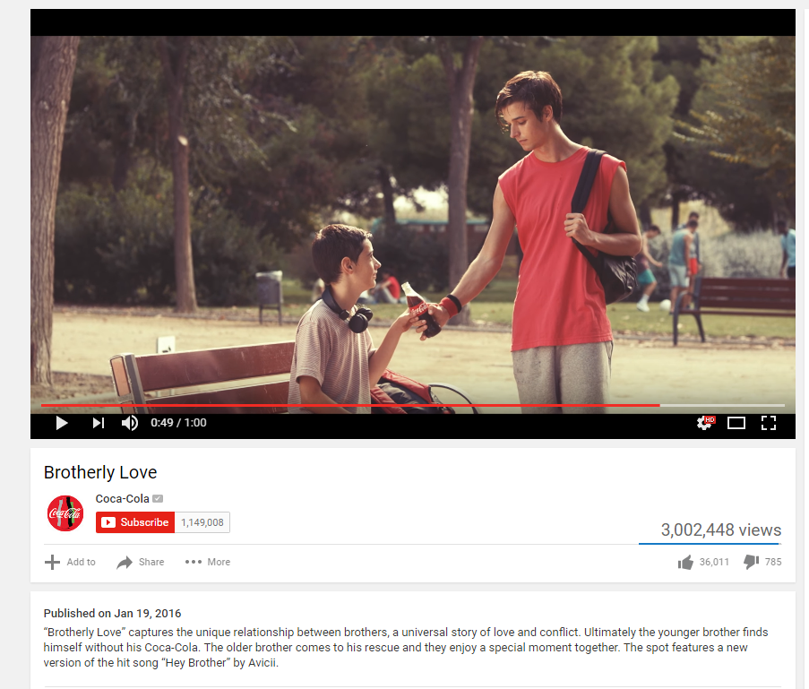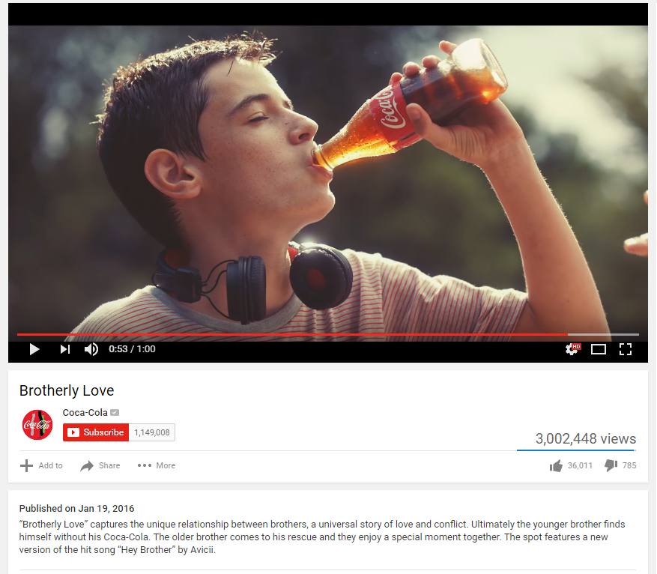
Figure 3, Brotherly Love campaign. 2016. Coca-Cola. At: https://www.youtube.com/watch?v=0oYlOBun8UI. [Accessed 13 December 2016]
The campaign (Figure 3) follows the story of two brothers of which the younger is always being teased by the older brother, but in the end, the Coke bottle becomes the representation of their brotherly love. All symbolic meanings of love and caring for family are concentrated on the product itself. This advertisement incorporates both latent needs of love (sharing with loved ones) and basic physiological needs (thirst), through which marketers motivate consumers to choose Coca-Cola.
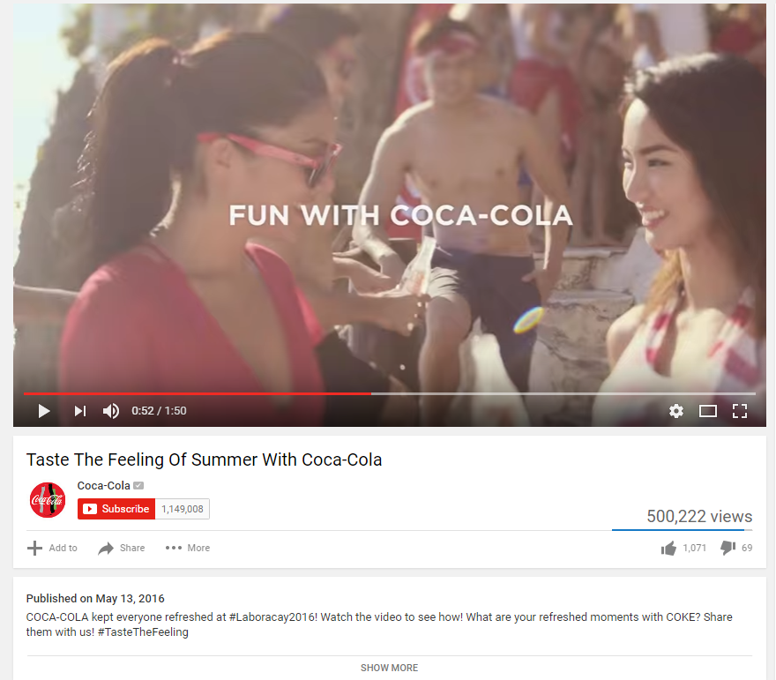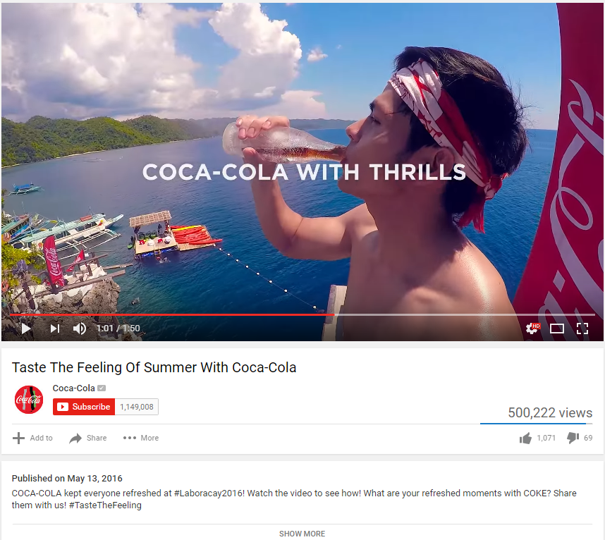
Figure 4, Taste the Feeling of Summer with Coca-Cola campaign. 2016. Coca-Cola. At: https://www.youtube.com/watch?v=F411acOyIzw . [Accessed 13 December 2016]
Here (Figure 4), Coca-Cola communicates notions of fun, action, excitement and thrill, all of which can be achieved (or satisfied) by drinking the product. This is shown through images of young people who are both adventurous and brought together through the shared Coke bottle. The campaign revolves around their new slogan, Taste the feeling, which attractively combines unconscious physiological needs (“taste”) with emotional notions (“feeling”), thus motivating consumers through different layers of their unconsciousness.
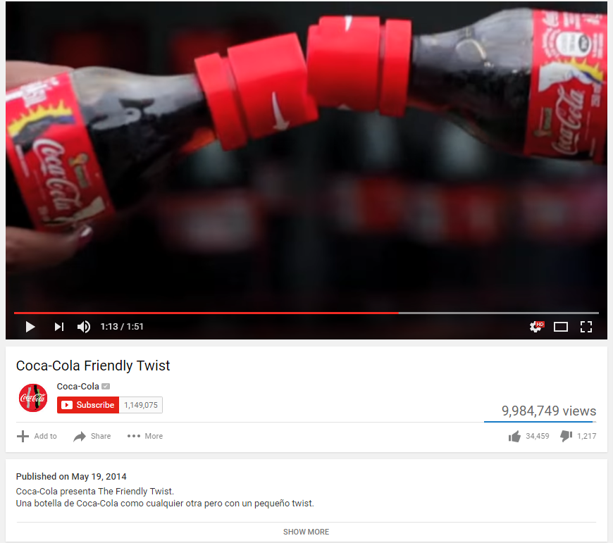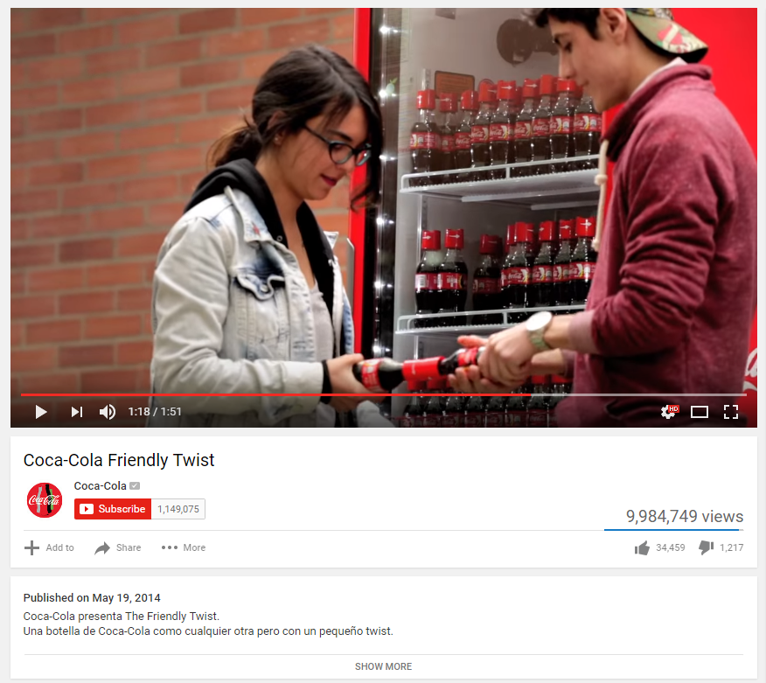
Figure 5, Friendly Twist campaign. 2014. Coca-Cola. At: https://www.youtube.com/watch?v=t9cmoT_wb0A . [Accessed 13 December 2016]
The Friendly Twist campaign (Figure 5) aims to bring people together by making them open their Coke bottles solely by matching the cap with another one. In this way, consumers are shown that they can become part of a community and connect with others through the product, thus satisfying their needs for belonging.

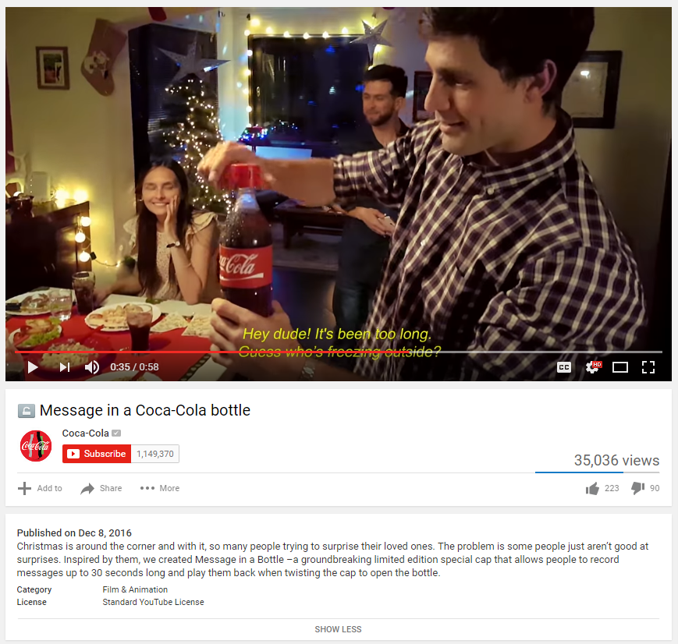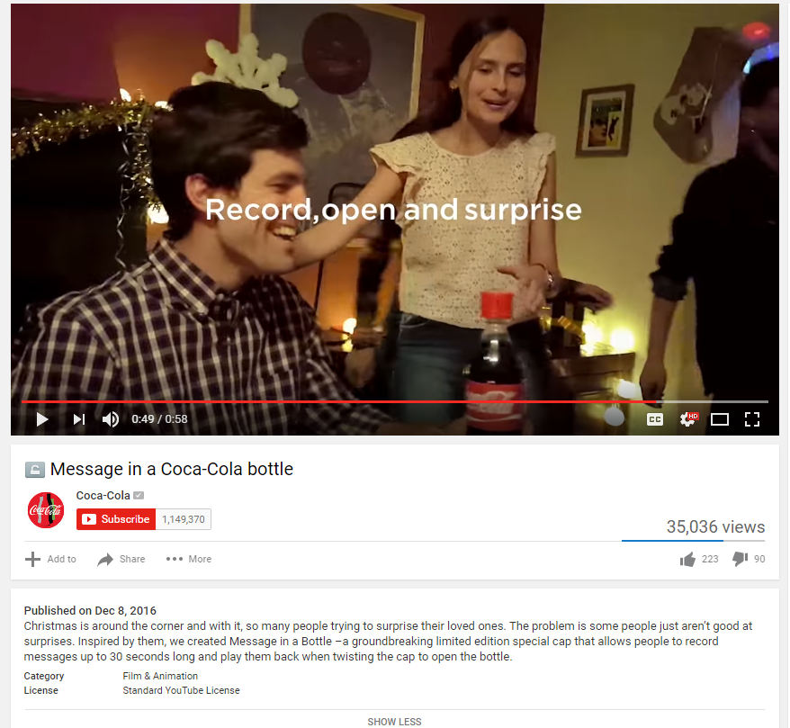
Figure 6, Message in a Coca-Cola bottle campaign. 2016. Coca-Cola. At: https://www.youtube.com/watch?v=S5kU_u9Ryrs . [Accessed 14 December 2016]
One of the newest Coca-Cola campaigns (Figure 6) presents a new invention. A limited number of Coke bottles will have caps with in-built audio recording technology, which consumers can share with friends and family (as it can be seen in the advertisement). Both this campaign and the previous one (Figure 5) show the innovative capabilities of Coca-Cola’s marketing team. They are able to increase consumer interest through new ideas revolving around social consumption and sharing.
Appendix D: Martin-Morich model of consumer behaviour
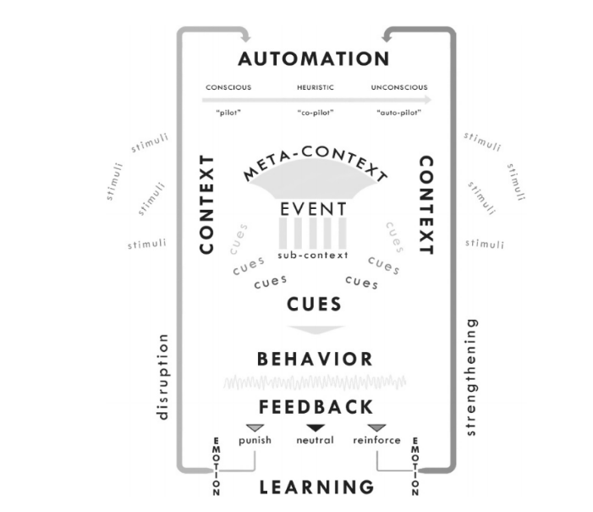
Figure 7, The Martin-Morich model of consumer behaviour (Martin and Morich, 2011)
This model (Figure 7) tries to incorporate the idea that both conscious and unconscious needs as well as contextual and environmental factors shape a consumer’s behaviour. According to the model, consumers behave based on how acquainted they are with their environment as a result of the process in which their “conscious awareness is dependent on the unconscious mind’s ability to interpret and process its surroundings” (Martin and Morich, 2011, p.495).

Appendix E: MindSight model
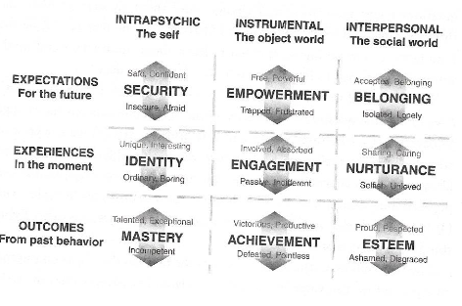
Figure 8, MindSight model (Forbes, 2015)
The MindSight model (Figure 8) is another attempt at unifying previous models of human motivation. Through this, human motives can be explained as the result of intrapsychic, instrumental and interpersonal factors which can be either positively or negatively charged (Forbes, 2015). Forbes (2015, p.31) also stresses on the fact that motives can occur both sequentially and randomly throughout individuals’ lives. Thus, marketers can only target a few, but not all of those drives in a single marketing campaign.

Appendix F: Victoria’s Secret Campaign
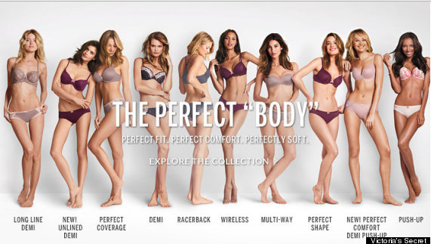
Figure 9, The Perfect Body campaign. 2014. Victoria’s secret. At: https://www.huffingtonpost.com/2014/11/06/victorias-secret-perfect-body-campaign_n_6115728.html. [Accessed 11 December 2016]
This campaign (Figure 9) aims to trigger consumer’s esteem needs. By choosing Victoria’s Secret products, consumers will be able to satisfy their unconscious needs of self-actualisation through this perfect body, which is also the name of their product. This wordplay received backlash for promoting unrealistic beauty standards (Bahadur, 2014). However, the campaign still represents how marketers aim to motivate consumer purchase by satiating their desires to possess such luxurious products, which carry social meanings.

Appendix G: YouTuber Zoella promotes new products
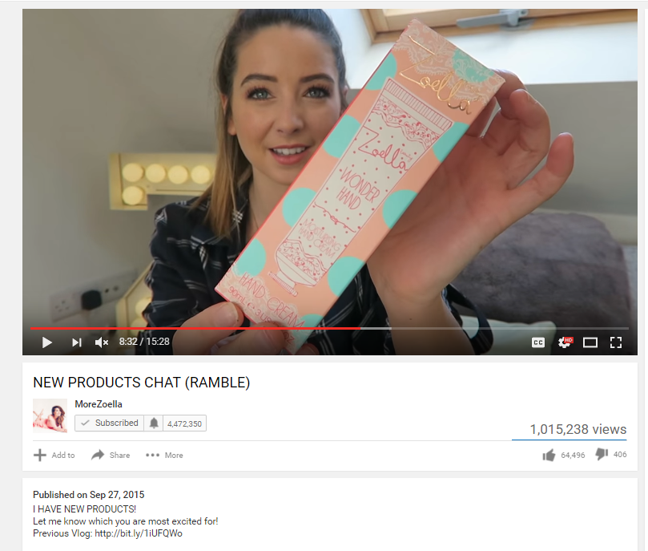
Figure 10, New Products Chat (Ramble). 2015. YouTube Channel: MoreZoella. At: https://www.youtube.com/watch?v=h55eRSznGN8 . [Accessed 10 December 2016]
In her video (Figure 10), Zoella promotes new products from her beauty line. Having previously built a large audience, she is able to release a product that her followers would be motivated to buy due to her social media influence on them. The screenshot additionally shows the large amount of views this video received, which represent Zoella’s influential power.
Appendix H: Landing page of Lynda.com
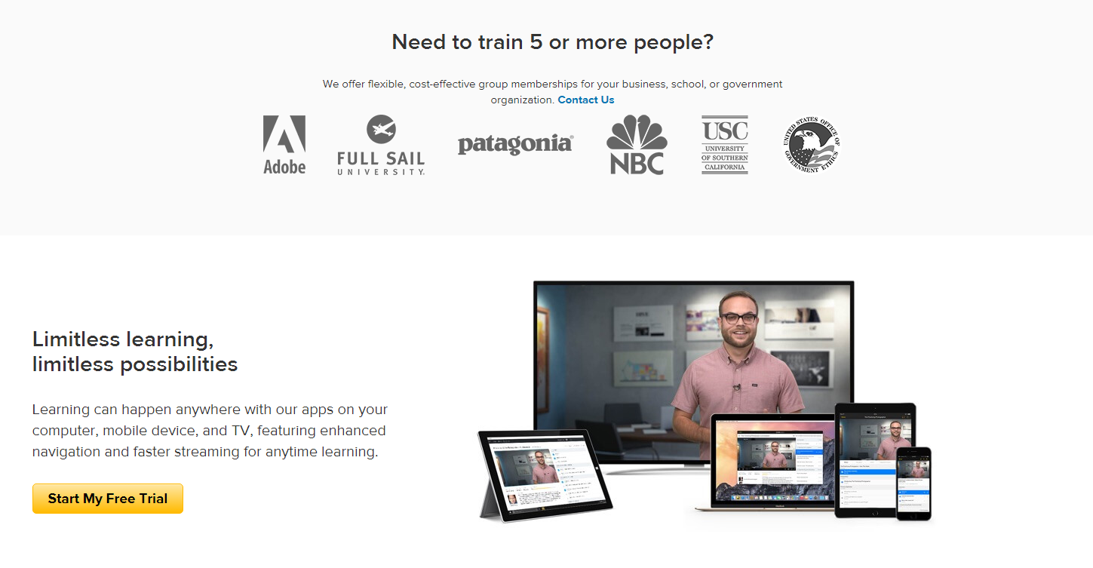
Figure 11, Landing page. Lynda.com. At: https://www.lynda.com/ . [Accessed 13 December 2016]
Lynda.com’s landing page (Figure 11) is an example for motivating and connecting people through digital technologies. The website incorporates an easy-to-navigate style with photos of individuals, to whom consumers visiting the page can relate to (this is also achieved through the Jules’s testimonial of service use and achievement of learning a new skill).

